# **Upgrad BookMovieApp**

# **Submitted By**

# Rashi Bindra

# Vaibhav Pandita

# Harshita Karahe

# BookMovieApp

About:

Through this application users can browse upcoming and released movies; filter released movies based on certain parameters; and view details such as genre, artists and trailer of released movies.

Also, registered users can book a show for a released movie.

Project source code URL:

<https://github.com/toxiczephyr08/BookMyMovie>

Application features and pages:

There are 4 main pages/features available in this application. Here is the list of features along with respective developed pages screenshots.

1. **Login/Register Modal**

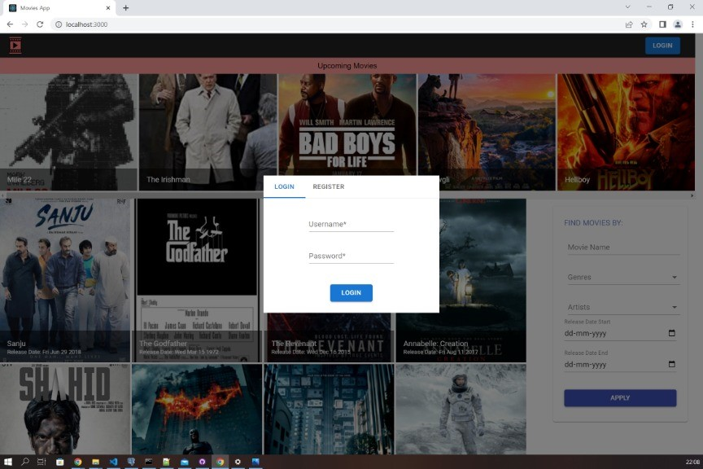

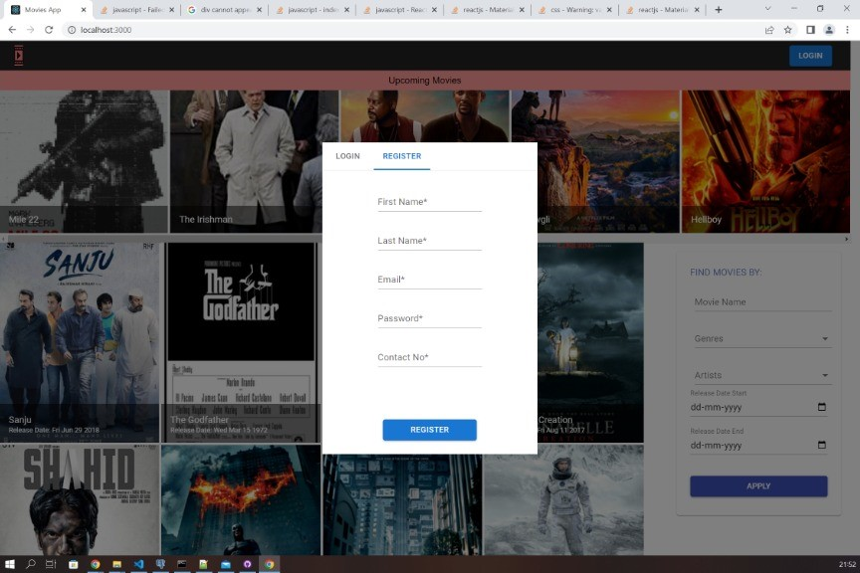

1. **Home Page**

Before applying filter

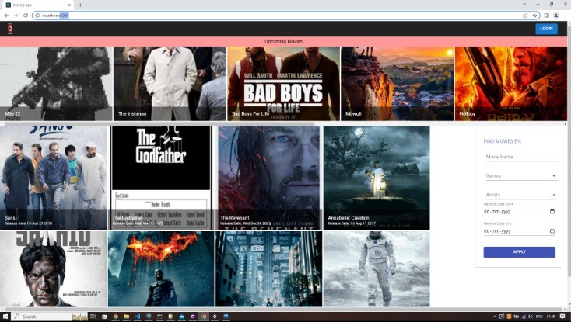

After applying the filter

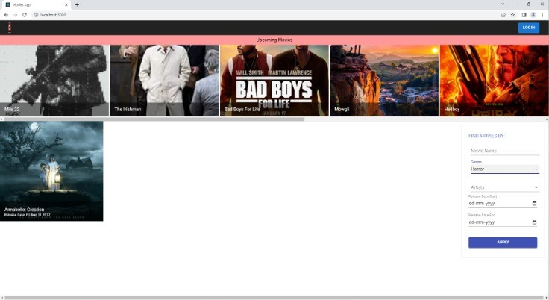

1. **Movie Details Page**

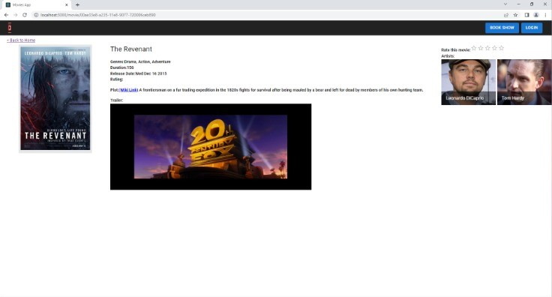

1. **Book Show Page**

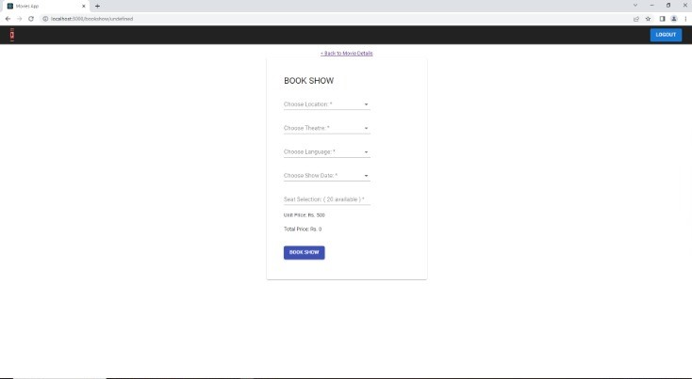

Roles and Responsibilities:

|  |  |  |
| --- | --- | --- |
| Name | Contributed to project | Roles & responsibilities |
| Rashi Bindra | Yes | * Setup project in local system. * Database setup * Github setup. Created new repository and cloned for tracking and committing changes. * Developed all the features and pages required for this application. Pushed the changes to GitHub repository. |
| Vaibhav pandita | No | Zero contribution |
| Harshita Karahe | No | Zero contribution |